ANNUAL PROJECT REPORT
STRENGTHENING NATIONAL SYSTEMS FOR UNCAC IMPLEMENTATION (SNS4UNCAC)

February 2018

General project information

Country: Belize
Project Title: “Strengthening National Systems to Support UNCAC Implementation in Belize”
Project Number: Project ID 000100299 (Atlas)
Implementation site: Belize
Period: January 2017 – December 2019
Budget: $470,000 USD ($220,000 from UNDP and $250,000 from CARSI)
Implementing partner: UNDP
Type of budget execution: Direct Implementation Modality (DIM)
Contact person: Roxanna Aleman, Project Assistant, UNDP Belmopan Roxanna.aleman@undp.org
Supervisor: Karen Bernard, Deputy Resident Representative. UNDP Belmopan. Karen.bernard@undp.org

Description of project achievement

2.1. Original project purpose and degree of its achievement level
It is proven that corruption undermines human development and democracy, and it is often the most vulnerable who suffer first. Corruption reduces access to public services by diverting public resources for private gain. There are gendered dimensions to corruption, as men and women have different experiences with and perceptions of corruption. In order for countries to effectively manage limited resources and contribute meaningfully to their sustainable development, there has to be substantial reduction in corrupt practices.

Based on the recognition of the above, Sustainable Development Goal 16 (Promote peaceful and inclusive societies for sustainable development, provide access to justice for all and build effective, accountable and inclusive institutions at all levels) calls for a substantial reduction in corruption and bribery in all their forms. Target 16.5 recognizes the importance of a reduction in public perception of corruption as well as the need for transparency in public budgeting and expenditure.
Belize has been affected by a narrowing fiscal space and therefore the need for resources to be efficiently and equitably allocated is amplified. The Government of Belize has recognized the need for improved governance that is transparent and accountable to ensure that as resources become scarcer, that they are appropriately channeled. Likewise, civil society has been vocal about the need for increased measure to combat corruption and channel resources to the most vulnerable.

As a result and following intense, public, private sector and civil society pressure, Belize acceded to the United Nations Convention Against Corruption (UNCAC) in December 2016. The UNCAC Self-Assessment often takes place following the ratification of or accession, both to feed into the UNCAC Review Mechanism and to assist the government identifying compliance issues and subsequently prioritize and sequence its anti-corruption reforms.

This project employs UNDP’s ‘Going beyond the Minimum’ Approach to ensuring meaningfulness to the UNCAC ratification process. In addition, this project will draw on the technical expertise from both UNODC and UNDP in supporting the government in implementing the UNCAC. Recognizing the validating role of civil society, this project will work with the government in encouraging CSO, including women’s organization participation during the assessment, planning and capacity development processes. Additionally, the project will employ a rigorous public information and advocacy campaign in an effort to address the embedded cultural acceptance of corruption.

At the end of the Project, the country will have an improved and gender sensitive national system to facilitate the effective implementation of the UNCAC, and ultimately reduce the levels of corruption nationally.

It should be noted that the project has a diverse and very active Board, with consistent high level participation from one Minister, two CEOs, one Senator, and opposition political party, in addition to Financial Intelligence Unit (FIU) and CSOs including Belize Network of NGOs, Belize Chamber of Commerce and Industry (BCCI), churches, and National Youth Council.

2.2. Project outputs and activities

Output 1. Gender sensitive assessments

Activity 1.1: Completion of mandatory UNCAC country self-assessment

The project facilitated the Belize government’s compliance with their obligations under UNCAC. In this regard, the country’s designated National Focal Point – the Attorney General - travelled to the UNCAC Secretariat in Vienna on two occasions. Under his leadership, the country completed the mandatory on-line self-assessment of the national systems for prevention of and addressing corruption, and two peer review countries were designated to review this assessment in early 2018.

Activity 1.2: National survey on gendered impacts of corruption

A nationwide survey on gendered perceptions and experiences with corruption was undertaken, with more than 300 persons from all six districts of the country surveyed. The analysis and draft report is completed and ready to be launched in early 2018, as part of the public engagement process and to promote reflection and discussion.

Output 2: Institutional architecture and national capacity

Activity 2.1: South-South Exchange with Jamaica

Ten board members, including government and CSO partners, travelled to Jamaica to participate in a study tour to view Jamaica’s best practices in addressing corruption, as a comparable SIDS country in the region, to see what could be learned and applicable for Belize.

The key findings included:

- Jamaica’s institutional framework is adequate to fulfill the requirements of UNCAC. Organizations such the Major Organized Crime and Anti-Corruption Agency (MOCA), the Revenue Protection Division, and the Anti-Corruption Commission are examples of good practices institutions which demonstrate practical examples of how the convention is implemented nationally. There are fewer specialized anti-corruption bodies in Belize with the necessary investigative powers.

- Jamaica’s public procurement process is more in line with UNCAC’s requirements of transparency, fairness, and accountability. Public procurement legislation is being amended to ensure that the principles previously mentioned are mandated by law.

- Jamaica emphasizes educating the general population, particularly youth, to both prevent and eradicate the culture and acceptance of corruption. There is a holistic approach to addressing corruption in Jamaica, shown by a focus on corruption in both the private and public sectors (which extends to the political and civil servant levels).

- There are covert, informal, and user-friendly reporting mechanisms which create the requirements necessary for anonymity. For example, to provide whistleblower protection, hotline calls are not answered nationally.
- Civil society plays a critical role in building the core of a social movement for integrity. The National Integrity Action advocates and oversees the enactment of new legislation designed to strengthen transparency and accountability in governance. Part of the advocacy is demanding the enforcement of the law against corruption and ensuring that anti-corruption agencies function effectively.

The full report from this exchange is included as an Annex.

Another south-south activity brought an expert from Botswana – a Senior Anti- Corruption Officer from that country’s Directorate on Economic Crime and Corruption – to share best practice from that country. He made a presentation at the National Symposium on Corruption, and also conducted two TV interviews.

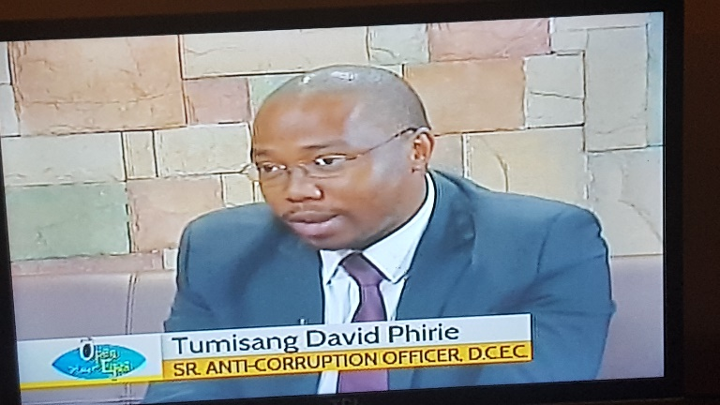
1 Anti corruption expert from Botswana gives TV interview in Belize

Activity 2.2: Technical trainings for govt and CSOs

Relevant technical training to build the capacity of the government and CSO partners in their respective roles for UNCAC implementation in Belize, including:

- Training delivered by UNODC on Introduction to UNCAC and its Review Mechanism – Belize City – Feb 2017
- Training on judicial integrity – Vienna – Chief Justice – May 2017
- Training on role of integrity commissions – Panama – Crown Counsel of Ministry of the Attorney General- June 2017
- Training on special auditing techniques for asset declaration – FIU and BCCI – October 2017

Activity 2.3: Expert Panel Discussion on Corruption on 1st anniversary of UNCAC accession

An expert panel discussion was also held to commemorate the 1st anniversary of the signing of UNCAC. Panelists included the Resident Representative of UNDP, The Regional Coordinator of Governance, Attorney General and President of Teachers Union. These four panelists attracted a group of 60 attendees to the session, where the following topics were presented upon. Topics included, “The strength of the utilization of the UNCAC in the fight against corruption in countries globally, the applicability of the UNCAC to states who have acceded to the convention, and what has the accession to the UNCAC meant for Belize”. In addition to the presentation on the above topics by the four panelists, there was also an opportunity for the attendees to ask and direct questions of concerns and interests to a specific panelist. There was active participation during the question and answer session from the attendees and panelists.

2. Senator, UNDP expert, UN Resident Coordinator and Attorney General on panel at event to commemorate 1 year of UNCAC implementation in Belize.

Activity 2.4: A National Symposium on corruption

This symposium was held in December 2017, with the following objectives:
- Update on status of UNCAC implementation in Belize;
- Discussion on the need to enhance State institutions/human resource and civil society organizations’ capacities to implement anti-corruption programmes and policies nationally;
- Learning from the experience of other countries that have made significant progress with the implementation of the UNCAC;
- Producing concise recommendations following the symposium to advance the fight against corruption in Belize.

The symposium attracted over 40 attendees from academia, LGBT, the opposition, government representatives, CSOs, youths and women. It was an all-day interactive session between attendees and panelists. The keynote speaker was a senior anti-corruption officer at the Directorate of Economic Crime in Botswana. The first session of panelists included the Attorney General and Deputy Resident Representative of UNDP who presented on the status of UNCAC implementation in Belize. The second session included panelists who shared their experience during their study tour to Jamaica to review Jamaica’s anti-corruption mechanisms and lessons learned. In the final session, the keynote speaker addressed the audience sharing their country’s success and challenges, along with three female panelists representing the NGOs, Chamber of Commerce and Attorney General ministry who elaborated on the path Belize is charting forward in the fight against corruption.

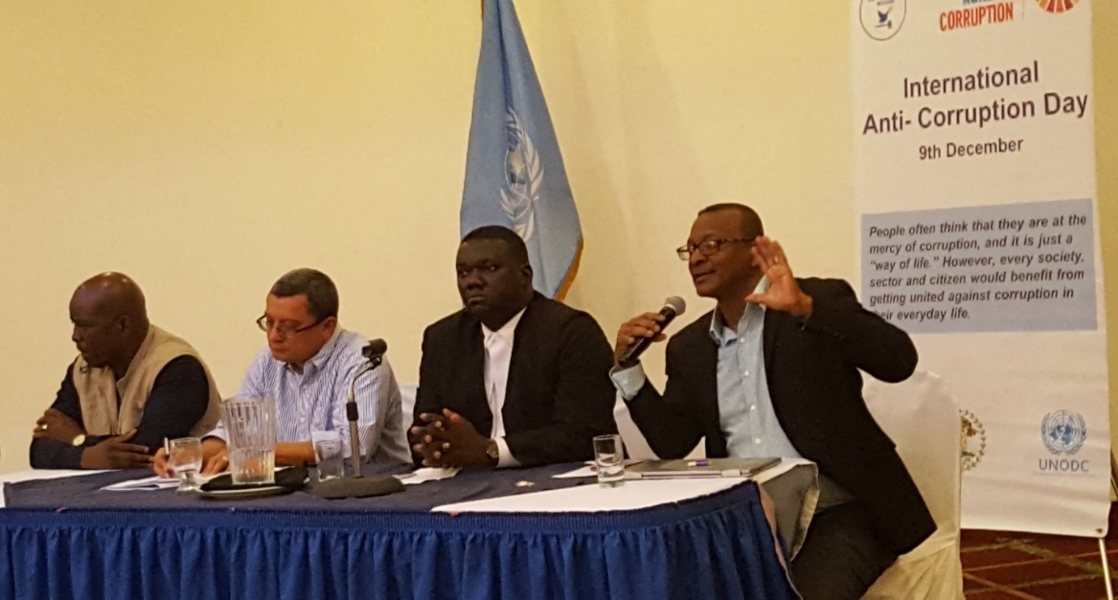
3. Board members from FIU, Solicitor General, Senator and trade unions on panel at National Symposium.

Output 3: Awareness of corruption and reform agenda

To lead up to the commemoration of International Anti-Corruption Day 2017, a series of activities were held, including anti-corruption school trainings, essay contest, logo competition, jingle competition, TV talk shows, a national symposium featuring national and regional experts, and a study on gender and corruption. The training on anti-corruption values for children was be delivered as an effort to reach out to all citizens on this vital development issue.

Activity 3.1: Activities to engage youth and public on anti-corruption

Several activities were carried led by UNDP and BNN (Belize Network of NGOs) to commemorate the one year anniversary of Belize acceding to the convention. A jingle competition was carried out engaging youths in arts to participate in creating an original jingle focused on anti-corruption. Entries were received from both female and male local artists. A logo competition was completed, engaging the community at large, inclusive of youths to partake in being creative and in coming up with a logo for the UNCAC project. An essay competition was also one of the highlights of the event where 40 participants from secondary and tertiary level institutions submitted their experience and exposure to corruption, and their recommendations on combatting corruption, with the winning essays publishes in the national newspaper.

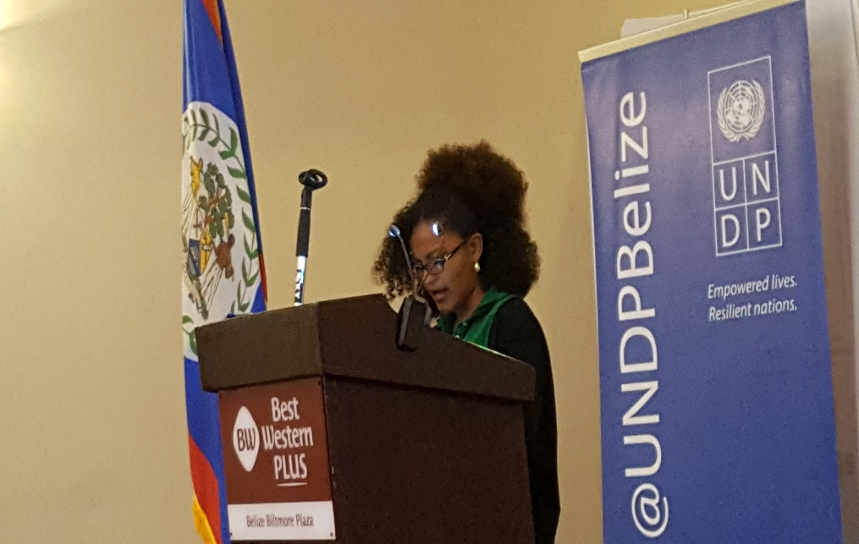
4. Student Julissa Torres reading her winning anti-corruption essay at the National Symposium.

Activity 3.2: Knowledge products

Key knowledge products prepared and disseminated under the project include:

- Video interview with Chief Justice Kenneth Benjamin on judicial integrity and its relation to UNCAC , found at this link:
https://youtu.be/JyWPqa0JvEc

- Video on UNCAC implementation in Belize, found at this link:
https://youtu.be/V5z2VaeW83E
- Glossary of corruption terminology for students (included as an Annex)

Activity 3.2: Training for students on anti-corruption

Anti-corruption trainings conducted with primary school students in 3 districts. Anti-corruption training for students was launched in collaboration with UNODC (United Nations Office on Drugs and Crime). To engage younger children, international expert Debra Rodriguez, based in Panama with the United Nations Office on Drugs and Crime (UNODC), came to Belize to facilitate these trainings in primary schools. The approach uses cartoons, a specially designed coloring book, fuzzy characters, and talent shows organized by the children themselves to talk about core values which tend to prevent and protect people from engaging in corruption.

The Values Program is designed for children between the ages of 5 to 9 years. The values that it promotes are: honesty, tolerance, liberty, gratitude, solidarity, justice, responsibility, loyalty, respect and generosity. To engage students, UNODC provides them with a colouring book which depicts these 10 values through pictures and words.

The trainings were held initially at public schools in Belmopan, Dangriga, Pomona Village and Hattieville. A total of 238 students participated, throughout the three days. At the end of the training, the children will have gained a better understanding of these values, situations where they may need to practise them, and how exercising these values can contribute to good citizenship.

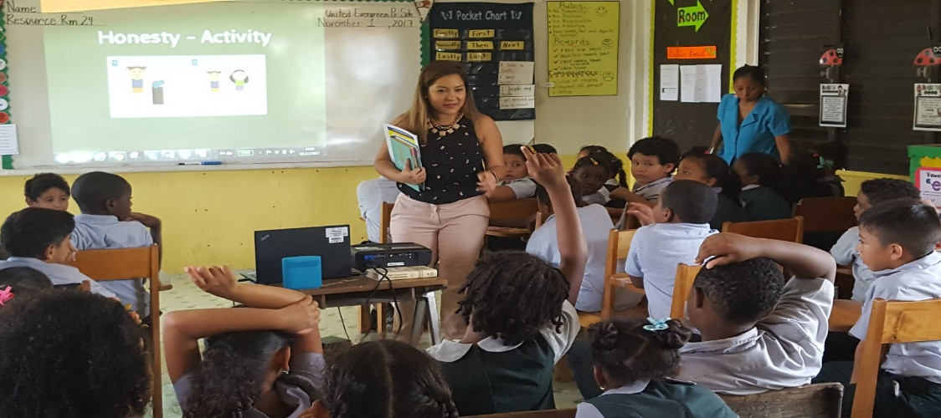
5. Expert from UNODC Panama training schoolchildren on values which prevent corruption.

Anti-corruption training to secondary and tertiary level institutions was conducted in 5 districts. To engage secondary and tertiary students, a team from UNDP Belize, in cooperation with UNODC in Panama, has been deployed. The team has already visited the University of Belize in Belmopan, Galen University, Stann Creek Ecumenical Junior College, and Corozal Junior College. Institutions to be visited soon include Our Lady of Guadeloupe Catholic High School in Belmopan and Muffles Junior College in Orange Walk. The team hopes to visit secondary and tertiary institutions in every district, with hundreds of students participating in this important endeavor. Total of 221 students were trained at 9 high schools, colleges and universities across Belize.

The team’s approach includes communicative sessions to talk about the nature and definition of corruption, the causes of corruption and strategies to fight it, as well as the basics of the United Nations Convention against Corruption. In addition, students engaged in an eLearning module developed by the United Nations, “Introduction to Anti-Corruption,” which will allow students who successfully finish to receive an official UNODC Certificate of Completion.

At the end of the training, the students had gained a better understanding of the principles of anti-corruption and practices and strategies to reduce and, hopefully, eliminate corruption. The students will learn how exercising these values and strategies can contribute to good citizenship, as well as to a more prosperous and equitable Belize.

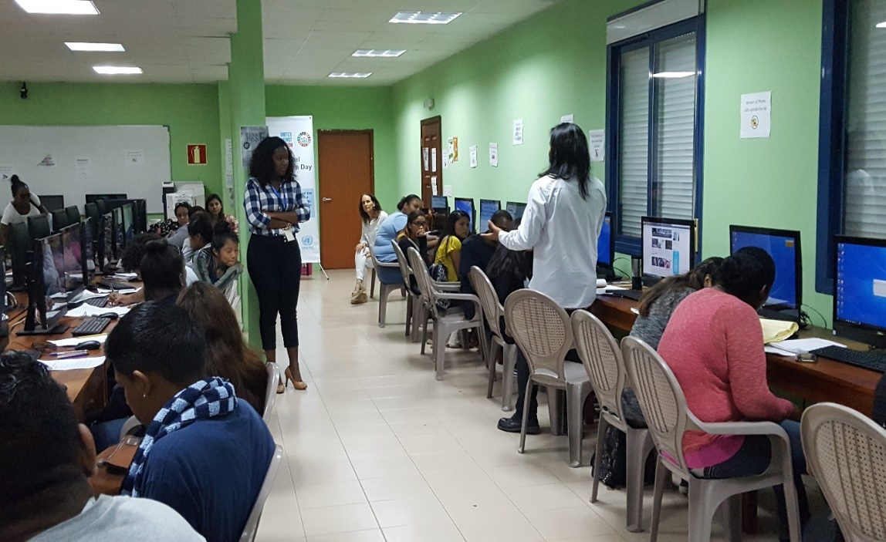
6 Anti-corruption training session for students at University of Belize.

2.3. Sustainability of the project achievement and outcomes

The project has a solid foundation which indicates its sustainability. From its inception, it was created at government request for UN support on this issues, following a social movement demanding actions on corruption and the signing of UNCAC specifically. As the Project Board embraces a broad diversity of social actors, this ensures ongoing robust discussions and determination of actions and responsibilities.

2.4. Other positive/negative impact by the project
This project has increased the awareness of anti-corruption among the public, and youth in particular. It has also enhanced the knowledge and exposure of the board and some government employees in the Attorney General Ministry on the process of UNCAC, and anti-corruption best practices and plans that can be implemented in Belize and be of impact to the country.

Also, as the project has promoted and disseminated information on UNCAC and anti-corruption to various social sectors, and through a range of media and platforms, this has demonstrated to the population that the country is moving forward on this issue as expected. Therefore, the social unrest and violent clashes seen prior to the signing of UNCAC have not transpired during the project.

No negative impacts have been observed.

Quick evaluation

The following aspects provide a quick evaluation of the project:

3.1. Visibility of partnership with Attorney General Ministry and CSOs
The Attorney General Ministry has been the focal point for the implementation of UNCAC; therefore we have maintained a close and cordial working relationship with them. Also the CSOs including BCCI have been actively involved in the UNCAC implementation process, and are great advocates for anti-corruption regimes to be in improved.
The Attorney General has been at the forefront of the panel discussion and national symposium held on anti-corruption, as a featured speaker at both events. He has spoken on where Belize is in the UNCAC implementation process, and the government’s support in the UNCAC implementation. Overall, the participation and support of the Attorney General ministry is very active and visible.

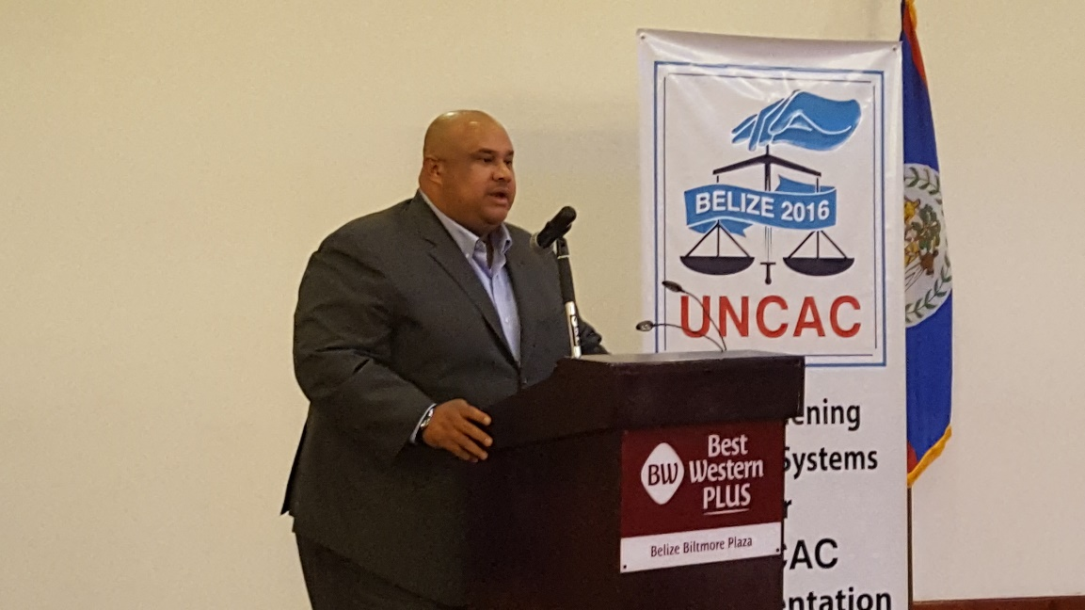

7 The Attorney General, designated as the country's National Focal Point for UNCAC, speaks at the National Symposium.

3.2. Relevance as UN/UNDP work
This project is highly relevant to UNDP and to the entire UN system, as the corruption scandals are unfolding in many UN member countries in the last two years. This is the first project focused on anti-corruption in conjunction with the Government of Belize implemented in Belize in partnership with UNDP. Belize was the 182nd country to sign on to the UNCAC.

Lessons learned and recommendation for the future

4.1. New knowledge gained
Feedback from partners through training evaluations shows that the new knowledge gained in anti-corruption is appreciated, timely and applicable to the Belize context.

4.2. Design weaknesses/implementation constraints
Engagement of the National Youth Council did not meet the expectations, as they have not yet come on board to assist with youth advocacy and promote youth participation. This will be further pursued in 2018.

Despite high levels of participation in Board meetings, members are very busy with their ongoing work loads, so at times are not available to lead on some of the activities, defaulting to UNDP leading.

Recommendations
- The school training methodology can be slighting enhanced based on feedback from the students’ evaluations, and should be extended to cover additional schools across the country. Toledo district is top priority, as it was the only district missed so far
- Technical training needed on specific topics related to UNCAC implementation, such as legislative drafting and public procurement.
- Advocacy products in 2018 should build on the work and engagement to date, and capitalize on the winning entries from public competitions

Annexes

Analytics on school training
Flyer for essay competition
Analytics on essay competition
Flyer for jingle competition
Glossary of anti corruption terminology for students
Report from south-south exchange in Jamaica

